Queensland
Integrity Commissioner ANNUAL REPORT 2018–2019
Encouraging confidence in public office
& public institutions

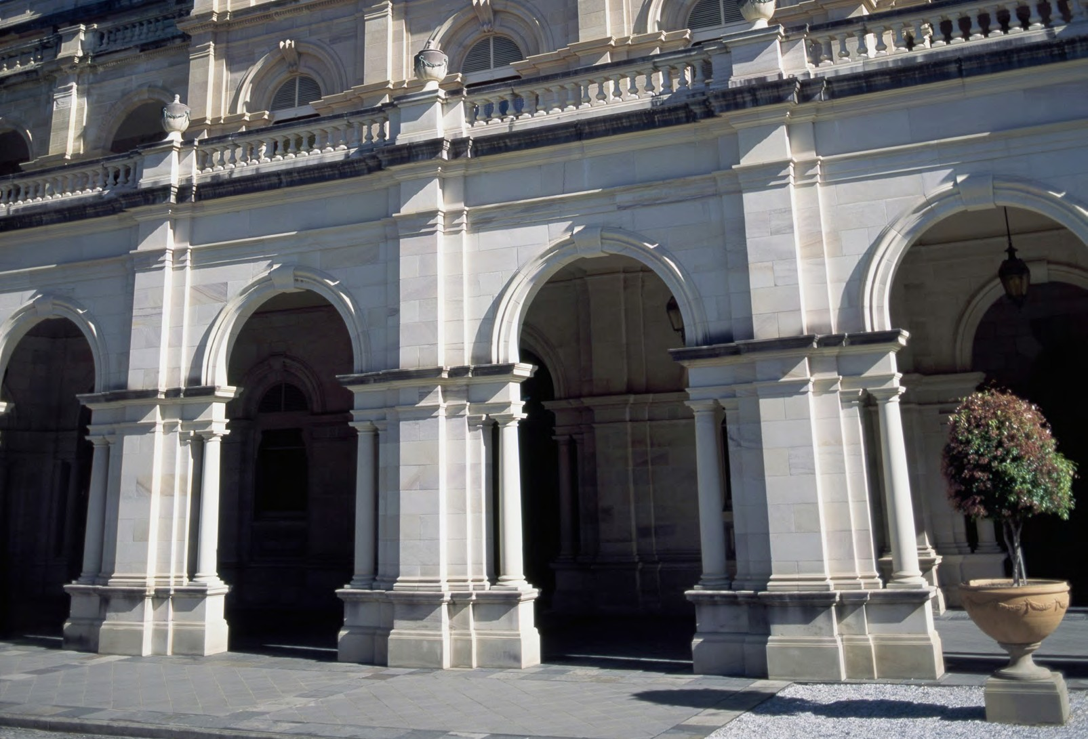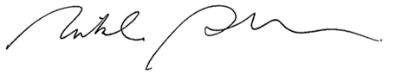

The Honourable Curtis Pitt MP Speaker of the Legislative Assembly Parliament House
George Street
BRISBANE QLD 4000

Dear Mr Speaker

I am pleased to provide you with the Queensland Integrity Commissioner Annual Report 2018-2019. This is the second annual report since my appointment as Integrity Commissioner, and the tenth report under the provisions of section 85 of the Integrity Act 2009.

The Annual Report covers a further period of unprecedented demand in requests for the services of the Integrity Commissioner including requests for advice, and requests in line with the public awareness raising function of the Commissioner.

It has been a rewarding and eventful year, with a noticeably heightened awareness of
integrity standards across all sectors.

I wish to acknowledge the support and dedication of the staff who have supported me to fulfil my statutory obligations, and those in public office and public institutions who have responded to the community’s desire for a heightened level of integrity and ethical awareness in the public sector.

I confirm the Annual Report complies with section 85 of the Integrity Act 2009.

I also confirm the Annual Report is in general terms and does not contain information likely to identify advisees.

Yours sincerely

Dr Nikola Stepanov PhD (Melb.) Queensland Integrity Commissioner 27 September 2019

WELCOME
This Annual Report covers the 2018–2019 financial year, and draws to a close my second year as the Queensland Integrity Commissioner.
2018–2019 was another year of unprecedented demand for advice on ethics and integrity issues. We received 394 enquiries
and requests, of which 274 required a formal written advice.
This built upon the demand in the 2017–2018 financial year, where I experienced a four-fold increase in the number of
requests for advice. Requests for advice in 2017–2018 rose to 216 requests compared to an average of 40 requests per year since the inception of the Integrity Commissioner.
The continued increase in demand for advice suggests that users value this unique advisory service I provide and it is indicative of an ongoing commitment to ethics and integrity by those with public responsibilities.
I continue to be deeply committed to raising public awareness of ethics and integrity issues, including among public office
holders and public servants. However, I acknowledge that the heightened demand for advice, and the fact that I am unable to delegate the formal advice function, limits my ability to conduct as many workshops and training sessions as I would prefer.
Certainly, I remain encouraged by the number of designated persons seeking advice on complex ethical and integrity issues. In my view it indicates a commitment to maintaining public confidence in government decision-making, and I am excited about ongoing work and engagements with our collaborative partners.
– Dr Nikola Stepanov

CONTENTS
4 About Us
5 2018–2019 Dashboard
- Strategic Plan 2019–2022
- Integrity Function

- Lobbyists Function
- Public Awareness Function
- Compliance Disclosures
- About this Report

ABOUT US

MESSAGE FROM THE DIRECTOR
The number of advices
provided by the Integrity
Commissioner during the
2019 financial year was at an historical high.
In April 2019, amendments to the Integrity Act 2009 also increased the range of
‘designated persons’ who could seek the Integrity Commissioner’s advice.
Former designated persons can now seek advice with respect to post separation obligations. These include restrictions on meeting government representatives
during post separation quarantine periods, ranging from two years to 18 months.
Senior executive and senior officers may also now seek the Integrity
Commissioner’s advice without first
obtaining their chief executive’s approval.
To help meet increased demand, the office has enhanced its website, and published various guides and case studies on
common fact scenarios. These resources will continue to expand as we explore additional ways to meet demand.
– Mr Michael Vickers
THE QUEENSLAND INTEGRITY COMMISSIONER
The role of Queensland Integrity Commissioner was initially
established in 1999 under the
Public Sector Ethics Act 1994.
The Integrity Act 2009
transferred and updated the provisions of the Public
Sector Ethics Act 1994
concerning the Integrity Commissioner, and expanded the responsibilities.

Dr Nikola Stepanov was appointed by
the Governor in Council on 1 July 2017 as
Queensland’s fifth Integrity Commissioner.
Her appointment is for a three year term, which expires on 30 June 2020.

Dr Stepanov has spent much of her career in service to the public sector and community. Her background includes:
- professional ethics and governance
- research and research regulation
- mediation and dispute resolution, and
- board governance.
She has particular expertise in resolving complex and contentious conflicts where there are grave personal or governance risks.

She holds five degrees, including a Juris Doctor (JD) and a Doctor of Philosophy (PhD). She completed her PhD at the University of Melbourne with the School of Global and Population Health and the Melbourne Medical School.

Dr Stepanov’s professional accreditation and memberships include:
  - Fellow of the Governance Institute of Australia
  - Mediator under the National
Mediator Accreditation System,
  - Family Dispute Resolution
Practitioner accredited by the Federal Attorney General’s Department, and
  - Professional member with the Resolution Institute.
In the mediation space, she has a strong interest in children’s rights, elder
advocacy, cross-jurisdictional property
matters, and cross-border treaty matters involving children with complex health needs.

Her community service roles include:
- President and Board Chair of the Brisbane Youth Service.
- Co-patron of the Corruption Prevention Network of Queensland (together with Mr Alan MacSporran QC, Chairperson, Crime and Corruption Commission).
- Committee member of the Australian Institute of Administrative Law.
- Steering committee member on the Health Ethics and Law Network.
- Member of the Queensland Children’s Hospital Ethics Committee.
Dr Stepanov is also an Adjunct Professor with the Division of
Tropical Health and Medicine at James Cook University, and
continues to supervise PhD students and to publish in various fields.

2018–2019 DASHBOARD

5000+
INTEGRITY FUNCTION (REFER PAGE 8)

335
274

38% 61

designated persons entitled to seek advice from the Integrity Commissioner:
⬇ Members of the Legislative Assembly, including:
⬇ The Premier
formal requests for ethics and integrity advice from designated persons
formal written advices issued
of formal written advices issued within 1 business day of request
formal requests not
within the scope of the
Integrity Act 2009

⬇ The Deputy Premier
⬇ Ministers
⬇ Assistant Ministers

LOBBYING FUNCTION (REFER PAGE 9)

PUBLIC AWARENESS FUNCTION (REFER PAGE 10)

⬇ The Leader of the Opposition
⬇ Members of the Opposition, and
⬇ Other MPs
⬇ Statutory office holders
⬇ A chief executive of a department of government or public service office
⬇ A senior executive or senior officer (public service)
⬇ A chief executive of, or senior officer equivalent employed in, a government entity nominated by
the Minister responsible for administering the
16
enquiries about lobbying matters

GENERAL INFORMATION

100%
of entities audited and up
-to-date with compliance and contact details
60
education workshops and information sessions run state-wide
125
committees, meetings and events

entity
⬇ A ministerial staff member who gives, or a person engaged to give, advice to a Minister
⬇ An assistant minister staff member who gives, or a person engaged to give, advice to an Assistant
Minister
⬇ A person, or class of persons, nominated by a
Minister or Assistant Minister, including, but not limited to, Mayors and Councillors
33
enquiries from non- designated persons (members of the public)
10
media and right-to-
information enquiries
Amendments to the Integrity Act
⬇ Former designated persons may now seek advice with respect to post separation obligations for periods
ranging from two years to 18 months.
⬇ Senior executive and senior officers may now seek advice without first obtaining approval from their chief executive.

STRATEGIC PLAN 2019–2022
Ensure our workforce is Register is maintained
Not maintaining the aware of obligations to and up to date in order to register in accordance maintain register. Ensure oversee lobbyists' contact with statutory processes are in place for with government
obligations. registration and representatives. Audits
amendment of register. conducted regularly.
Regulate lobbyist activity
by maintaining the
register and encouraging ongoing disclosure.
Provide advice about lobbying when
requested.
Lobbyists
Function
Designated persons and
the public are aware of issues relating to ethics and integrity and the
Integrity Commissioner’s role and functions.
Implement processes to
incorporate integrity and ethics training to raise public awareness. Update website and conduct
stakeholder engagement plan.
Educate designated Lack of awareness about
persons and the ethics and integrity,
community about the thereby not fulfilling our Integrity Commissioner’s statutory obligations.
Public role and raising public Potential for loss of public
Awareness awareness of ethics and confidence in
Functions integrity. government.
THE ROLE OF INTEGRITY COMMISSIONER
The Queensland Integrity Commissioner is an independent officer of the Queensland Parliament reporting through
the Economics and Governance Committee.
OUR VISION
Encouraging confidence in public institutions and public
office.
OUR PURPOSE
The Integrity Commissioner has four functions under the
Integrity Act 2009:
- To give written advice to current and former
designated persons about ethics and integrity issues.
- To meet with and give written or oral advice to
Members of the Legislative Assembly about interests issues.
- To keep the lobbyists register and have responsibility for the registration of lobbyists.
- To raise public awareness of ethics and integrity issues by contributing to public discussion of these issues.
 | Objectives | Strategic Risks | Strategies | Performance indicators
 |  |  | Supporting our workforce | Our people are capable
 | To provide reliable, | Providing incorrect or | to meet deadlines. | and produce high level
 | appropriate and timely | unclear advice. Not | Training to ensure | results. We provide
 | advice to designated | providing advice in a | reliable, appropriate | advice in a reasonable
Integrity | persons on ethics and | timely manner. Loss of | advice. Putting quality | timeframe for the
Function | integrity issues. | reputation. | assurance systems in  place. | designated person’s  purpose.

Resolve
Value integrity by embedding integrity. Support and assist designated persons to resolve ethics and integrity issues in the public interest.
Lead
Value integrity by projecting integrity.
Show leadership by developing and promoting good practice standards for
ethics and integrity.
Engage
Value integrity by promoting integrity.
Engage with the public and public officials to raise awareness about ethics
and integrity, and the role of the Integrity Commissioner.
Challenge
Value integrity by contributing to research in the area of integrity.
Challenge misconceptions and myths around ethics and integrity.
OUR VALUES

INTEGRITY FUNCTION
Sections 7(1)(a) and 7(1)(b) of the Integrity Act 2009 set out two important functions of the Integrity Commissioner. The Integrity Commissioner gives formal advice to current or former designated persons on ethics or integrity issues.
Generally requests for formal advice must be received and responded to in writing, however, Members of the Legislative Assembly may also seek and receive advice orally. Members of the Legislative Assembly, including Ministers, may also
discuss their personal interests with the Integrity Commissioner without requiring formal advice. 22 such meetings occurred in 2018–2019. All discussions, whether formal advice is requested or not, remain relevant for satisfying obligations under the Ministerial Code of Conduct.
SOURCE OF REQUESTS
29 Premier, Ministers or Assistant Ministers

45 Statutory Office Holder

19 Chief Executive

12 Senior Exec./Officer

21 Ministerial staff

HEIGHTENED DEMAND
The Integrity Commissioner views the heightened demand for advice as being a very positive reflection of the current
201 Mayors/Councillors

1 Other
NUMBER OF REQUESTS
This financial year, the Integrity Commissioner received 335 formal requests for ethics and integrity advice, from which 274 were responded to with formal written advice. Of the remaining 61 requests:
- 35 requests were dealt with by preliminary oral or written opinion only
- 19 requests were referred to the most appropriate agency (e.g. Office of the Independent Assessor)
- 4 requests did not include chief executive authority required at the time of the request, and
- 3 requests were withdrawn.
335
Formal requests for
ethics and integrity advice

RESPONSE TIMES (BUSINESS DAYS)

38%

19%

16%

ethical climate and expects that the number of advice requests per annum will grow again in the next financial year. The significant increase in 2018–2019 is primarily attributable to the recent ministerial nomination of Mayors and Councillors as designated persons. In 2019–2020, a further increase is expected as the Integrity Act 2009 now classifies former
designated persons as able to seek advice and senior executives or officers no longer require chief executive approval to seek advice. This brings the total number of designated persons to over 5000 people.
RESPONSE TIMES
Despite efficiency measures introduced, the record number of advice requests received for the second consecutive year has resulted in a slight decline in response times overall. The Integrity Commissioner provided formal written advice
within 1 business day for 38% of cases and within 3 business days for a further 19% of cases. The principal reasons for exceeding 3 business days were complexity of issues or further information being required from the advisee. Given the predicted future demands, pressures on response times are anticipated to continue.
< 1 day

6–9 days
2–3 days

10+ days

22%

5%
4–5 days

TOPICS OF REQUESTS
This financial year, most requests for advice concerned potential conflict of interest issues in regard to:
NUMBER OF ADVICE REQUESTS

- shareholdings, property ownership and developments
36 Legislative Assembly
- managing the consequences of accepting donations
- conflicts arising due to employment/business interests
- acceptance of hospitality, gifts, and other benefits
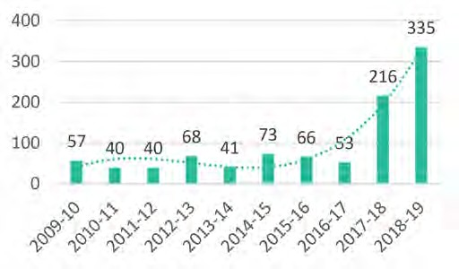
- competing statutory obligations, and
- Post separation issues from new/future employment.

LOBBYISTS FUNCTION
Section 7(1)(c) of the Integrity Act 2009 states that it is a function of the Integrity Commissioner to keep the lobbyists register and have responsibility for the registration of lobbyists.

REQUESTS FOR ADVICE ABOUT LOBBYING
This financial year, the Integrity Commissioner received 16 requests for advice about lobbying, 14 were responded to with formal written advice and 2 were referred to the Queensland Police Service and the Crime and Corruption Commission.

QUEENSLAND REGISTER OF LOBBYISTS
ABOUT THE REGISTER
The Integrity Commissioner has been responsible for administering the regulation of lobbying activities under the Integrity Act 2009 since 2010. This involves the maintenance of the Queensland Register of Lobbyists. The regulatory system is based on the requirement, under section 71 of the Integrity Act 2009, that ‘government representatives’ must not knowingly permit an entity that is not a registered lobbyist to carry out a lobbying activity for a third party client with the government representative.
Lobbyists are required to comply with a Lobbyists Code of Conduct which imposes a set of ethical obligations and responsibilities on professional lobbyists seeking to influence government policy and
decision making, while representing the interest of another person or body for a fee or other reward. This document is available online at: www.integrity.qld.gov.au/lobbyists/obligations-code-of-conduct.aspx
MAJOR AUDIT
In 2018–2019, the Integrity Commissioner commenced an extensive audit of compliance and useability
issues in relation to the Queensland Register of Lobbyists. During this process the Integrity Commissioner reviewed the registration of all entities and undertook a proactive approach towards currency of the
register and awareness of requirements for lobbyists. This involved confirming details were up to date
and discussing registration compliance obligations.
As a result, the Integrity Commissioner was satisfied as at 30 June 2019 that the compliance and contact details for all entities were in accordance with the Integrity Act 2009. A number of other issues were
identified including:
- difficulties associated with lost passwords
- declarations to ensure suitability may be too narrowly defined, and
- website content could be slightly streamlined.
As a result, improved systems were put in place to assist with password retrieval, the declarations were expanded to capture additional relevant information, and the website was re-evaluated and streamlined.

Registered De-registered

Lobbyists
105
263
12
20

Listed
Persons

PUBLIC AWARENESS FUNCTION
Section 7(1)(d) of the Integrity Act 2009 states that it is a function of the Integrity Commissioner to raise public awareness of ethics and integrity issues by contributing to public discussion of these issues.
A FOCUS OF THE INTEGRITY COMMISSIONER FOR 2018–2019
This financial year, being the 10th anniversary year of the Integrity Act 2009, the Integrity Commissioner set the theme of ’Decision-makers, Personal Interests, and Requisite Levels of Disclosure’ with an intent to improve awareness of the Integrity Commissioner’s role, and improve the understanding of ethics and integrity issues generally. This theme was used to guide the Integrity Commissioner’s public awareness initiatives, stakeholder engagements, and education activities during 2018–2019.
13 Departments/Agencies
4 Other Boards

INFORMATION SESSIONS
4 Hospital & Health Boards

DELIVERING THE MESSAGE ACROSS QUEENSLAND
18 Other
Throughout the year, the Integrity Commissioner had 185 public awareness interactions, delivering 60 information sessions to bodies such as statutory boards and local councils and participating in 125
committees, meetings and events. Also, the Integrity Commissioner website was enhanced with added case studies, fact sheets and guidelines. These documents are available online at:
www.integrity.qld.gov.au/publications/resources.aspx.

40 Presentations 15 Preliminary Education 5 QIC Sponsored Events
STATEWIDE TOUR OF COUNCILS 2017–2019

60
Information sessions
about ethics and integrity
21 Local Government
GUIDANCE MATERIALS AND STATEWIDE AWARENESS TOUR
The Integrity Commissioner also developed a guide and a series of meeting aids, in conjunction with the Independent Assessor, to assist Councillors in determining when a conflict of interest or material
personal interest exists. These documents are also available online at:
www.integrity.qld.gov.au/publications/resources.aspx.
In addition, the Integrity Commissioner and her team met with local government on 17 occasions.
Travelling to 12 different Councils throughout the year, the Integrity Commissioner was able to discuss ethics and integrity issues with 51 of 77 councils throughout Queensland, presenting either locally at the region or through local government collaboration forums such as Regional Organisations of Councils.
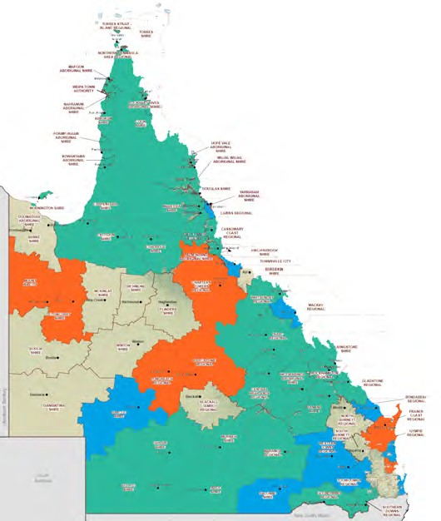RESEARCH
Councils visited by
the Integrity Commissioner or her staff
in 2018–2019
Councils presented to by
the Integrity Commissioner or her staff
in 2018–2019
Councils reached by the
Integrity Commissioner or her staff in 2017–2018
During 2018–2019, the Integrity Commissioner has been undertaking research into the obligations of persons on multi-member decision-making bodies (such as boards of Government-owned corporations) to identify, disclose, and manage their personal interests. From this, the Integrity Commissioner is finalising a comprehensive research paper, a step-by-step guide for multi-member decision-making
bodies and a series of meeting aids for members, including an easy-to-use flowchart. The purpose of the guidance framework is to provide assistance to these bodies and their members with their obligations. The Integrity Commissioner intends to publish these materials in 2019–2020.

COMPLIANCE DISCLOSURES
DECLARATIONS OF INTERESTS
Section 72C of the Integrity Act 2009 provides that various statutory office holders must provide a copy of their Declaration of Interests to the Integrity Commissioner. Similarly, chief executives are required by section 101 of the
Public Service Act 2008 to provide copies of their Declaration of Interests to the Integrity Commissioner. Section 85(2) of the Integrity Act 2009 requires the
Integrity Commissioner to provide details of compliance by statutory office holders and chief executives in this respect. As at 30 June 2019, all statutory office holders and chief executives had complied with these requirements.
Declarations made by Directors-General are now published on the Public Service Commission website, www.psc.qld.gov.au. In accordance with the Integrity Act 2009, the Integrity Commissioner has provided the Speaker with her own
Declaration of Interests and amended Declarations as necessary.
QUEENSLAND INTEGRITY COMMISSIONER
STATEMENT OF COMPREHENSIVE INCOME
Year ended 30 June 2019 | 2019 | 2018 | 2019 |  | Note
OPERATING RESULT | Actual  ($’000) | Actual  ($’000) | Original Budget ($’000) | Budget Variances ($’000) | Budget Variance
Income from Continuing Operations
Appropriation revenue | 1,309 | 722 | 1,418 | (110) | 1
Grants and other contributions | - | 68 | - | -
Total Income from Continuing Operations | 1,309 | 790 | 1,418 | (110)
Expenses from Continuing Operations
Employee expenses | 1,009 | 559 | 1,054 | (45) | 2
Supplies and services | 295 | 225 | 357 | (62) | 3
Grants and subsidies | 5 | 5 | 5 | -
Depreciation and amortisation | - | 1 | 2 | (2)
Total Expenses from Continuing Operations | 1,309 | 790 | 1,418 | (109)
Operating Result for the Year | - | - | - | -
OTHER COMPREHENSIVE INCOME | - | - | - | -
TOTAL COMPREHENSIVE INCOME | - | - | - | -
The following notes form part of this statement.
Explanation of major budget variances
- Original budget included additional funding of $0.230M reallocated from the Public Service Commission to support the Integrity Commissioner's operating requirements as a result of additional requests and advices supporting the governments commitment to integrity. Savings outlined in notes 2 and 3 reduced this requirement by $0.110M.
- A decrease in Employee expenses primarily due to short-term vacancies held throughout the financial year.
- A decrease in supplies and services primarily due to no requirement for consultancy fees or IT enhancements and lower than anticipated legal fees.

OTHER COMPLIANCE MATTERS
A copy of the Records Retention and Disposal Schedule (QDAN 629 v.3) developed for the Queensland Integrity Commissioner, and approved by the Queensland State Archivist on 22 November 2013, is available on the
Queensland State Archives website, www.archives.qld.gov.au. No public interest disclosures under the Public Interest Disclosure Act 2010 were received by the
Integrity Commissioner. One application was received under the Right to
Information Act 2009 in relation to lobbying. However, no applications were
received in relation to the advice functions of the Integrity Act 2009 and no
information can be provided about the Integrity Commissioner’s activities under Chapter 3 of the Integrity Act 2009. This Annual Report and previous reports
from the Integrity Commissioner are available online at:
www.integrity.qld.gov.au/publications/annual-reports.aspx.
MINISTERIAL CODE OF CONDUCT
Under the Ministerial Code of Conduct, Ministers and Assistant Ministers are obliged to meet with the Integrity Commissioner at least once each year. During the financial year, the Integrity Commissioner had meetings with or provided advice to each Minister and Assistant Minister.

ABOUT THIS REPORT
The Annual Report provides information about the Integrity Commissioner’s financial and non-financial
performance for 2018–2019. It has been prepared in accordance with the Financial Accountability Act 2009 and the Financial and Performance Management Standard 2009.
The Annual Report has been prepared for the Speaker and
the Economics and Governance Committee for tabling in
the Legislative Assembly.
The Queensland Government is committed to providing accessible services to Queenslanders from all cultural and linguistically diverse backgrounds. If you have difficulty understanding the Annual Report, you can contact us on 07 3003 2888 and we will arrange an interpreter to
effectively interpret it.
Copies of this publication can be obtained from
www.integrity.qld.gov.au or by contacting 07 3003 2888.

Licence

This Annual Report is licensed by the State of Queensland (Queensland Integrity Commissioner) under a Creative Commons Attribution 4.0 International License.
To view a copy of this licence, visit:
http://creativecommons.org/licenses/by/4.0/

Attribution
©The State of Queensland (Integrity Commissioner) 2019 The Queensland Government supports and encourages
the dissemination and exchange of information. However, copyright protects this document.
The State of Queensland has no objection to this material being reproduced, made available online or electronically but only if it is recognised as the owner of the copyright and this material remains unaltered.
Our office location and contact details are:
Level 13, 53 Albert Street
Brisbane QLD 4000
T: 07 3003 2888
E: integrity.commissioner@integrity.qld.gov.au
W: www.integrity.qld.gov.au
Copyright enquiries about this publication should be directed to the office of the Queensland Integrity Commissioner by email to:
integrity.commissioner@integrity.qld.gov.au or in writing to Level 13, 53 Albert Street, Brisbane, Qld, 4000.

Queensland Integrity Commissioner
Encouraging confidence in public office & public institutions

Level 13, 53 Albert Street
Brisbane QLD 4000
T: 07 3003 2888
E: integrity.commissioner@integrity.qld.gov.au W: www.integrity.qld.gov.au

